Eduardo Gonzalo Almorox[1] [2]

Nils Braakmaann

Volodymyr Bilotkach

John Wildman

First version: January 2017  
This version: May 2017

This paper investigates how house prices affect the market of care homes in England. Local markets where the house prices are high may disincentive the establishment of care homes and suppose a restriction in the access to long term care services. Alternatively, those markets with high prices may also suppose a business opportunity with a greater proportion of wealthier clients willing to pay more for long term care services. Considering the variation of the planning regulations accross local authorities authorities for addressing potential endogeneity in the house prices, our instrumental variables estimates suggest that higher house prices lead to a reduction of the distribution of care homes. Further analyses explore several possible mechanisms driving our results.

**Keywords**: Care homes, house prices, long-term care, England  
**JEL: R31, I12**

# Introduction

In the last decades, the English housing sector has experienced the fastest growth in prices amongst all OECD countries (evidence=). has been characterised by a high degree of fluctuation. These trends have had consequences in the society for both households, notably materialised in the so called “house affordability crisis”, and to less extent businesses. In this paper we investigate the effects of these price increases on the market structure of an industry that typically operates with low margins, the care homes that provide residential long term care services. Our interest in the long term care is not trivial. Elements such as the ageing of the population[3] or some socioeconomic changes such as the the inclusion of more women in the labour force or family structures with less members, are shifting the supply from the unpaid informal caregiving towards more formal long term care provision[4]. These patterns evidence the importance of this sector in the forthcoming decades. Yet, despite the will of policy makers to design policies that preserve a sustainable provision of long term care and that also ensure competitive market structures, there is limited evidence for the design of these policies. In this paper we aim at informing these policies by analysing the effect of high house prices on the entry pattern in the market of care homes.

The way high prices in the housing market may affect the local long term care markets is *a priori* uncertain, as there are two opposing effects that may appear. The first may consist of the effect of house price as a cost for running a care home. Hence, higher house prices may suppose an important barrier that can restrict the entry in certain local markets. Furthermore, higher house prices may increase the opportunity costs of alternative building projects and therefore provide an incentive to deter potential development of care homes.[5] A potential consequence derived from the former situations could be that people living in these areas may find lower long term care choices closer to them.

A more subtle effect is related to how house prices may affect the demand of long term care. In general, higher house prices reflect a greater level of quality in the area (Ross and Yinger, 1999) and are also associated with more economic opportunities . Besides, housing represents an important part of the household portfolio and then the formation of wealth among households is directly linked to the evolution of house prices . In the case of the potential clients of long term care, such as old homeowners, there is mixed evidence on how the house prices affect their wealth portfolio. Some authors argue that house prices are negatively affected by aged populations (see for example or ). The main argument is that people in younger ages are likely to have greater demand. Alternatively, houses can be considered as durable capital goods that could be monetized by old homeowners by selling them and moving out to cheaper areas . Previous literature on long term care markets has considered the level of prices in the housing markets as a good indicator of the payer composition .

If the former argument holds, areas with higher prices may be associated with greater levels of affluence and consequently greater proportions of clients that are more willing to pay for the services of a care home. Although the latter may contribute to preserve the financial viability of care homes in the market (an issue that constitutes a current public policy concern) and also incentivise their entry in these markets, it may also result in an unequal distribution of long term care across different areas in England. In this case, most affluent areas would be more benefited from a greater supply of home care services.

The main result of the paper is the negative effect that high house prices on the distribution of care homes. This effect suggest that a one standard deviation increase in the house prices, reduces the number of care homes per old population from about 0.2 to about 0. 4 depending on the instrument used. These results suggest that the providers’ decision is mainly driven by elements that determine the supply of the service and show evidence another social cost associated with the increases of the prices in the housing markets in England.

To obtain our results, we construct a dataset that merges information from several sources regarding the characteristics of the dynamics in the care homes market, the housing and the long term care markets and the planning regulations. Our dataset captures information regarding local authorities at different level (e.g. street, district and county level). A technical hurdle concerning our empirical analysis is linked to effect of house price on care homes entries. For example, it may be possible that the decision of care home providers for selecting certain markets where there are high house prices is driven by unobservable variables that make this decision non-random. This sample selection bias may invalidate the estimates corresponding to the effects of house prices. In order to overcome these, we carry out and identification strategy which uses an instrumental variables approach that exploits the variability in the restrictiveness of planning regulations across English districts. Our identification relies on the assumption that changes in the planning requirements affect the entry of care homes in market through the levels of house prices.

This paper contributes to the growing literature on the study of the residential long term care market in England. To the best of our knowledge, it is the first that provides causal evidence with regards to the effect of housing prices on the context of entries in the market of care homes. Yet, there are several papers close to the framework where this paper lands. , provide a detailed analysis of elements that determine the competition amongst care homes and assess the consequences of this competition in both prices and quality. Other authors, have explored the dynamics of the market by analysing potential elements that may lead to care homes closures. find that prices have a negative relationship with closures and investigate the effect of other effects such as the quality or the degree of competition. Their main result suggests that poorer quality and more competitive markets are elements that increase the probability of exit from the market.

We extend this literature by addressing issues referred to the entry process of care homes in local markets. Prior to this paper, only have provided some empirical evidence of factors affecting the market entry in the context of a minimum wage regulation. Their results suggest that the introduction of the minimum wage affects negatively the entry of care homes; although this effect seem to be not significant. In addition to providing a more up to date evidence, this research uses a more extensive dataset provided by the regulator, the Care Quality Commission (CQC). Likewise, this research also extends the literature that studies the effects of the planning system and the high house prices in England using the care homes as a sector for the analysis.

This paper is organised as follows. Next section, section [sec: institutional], outlines the main institutional characteristics of the English local government. Section [sec:data] describes the data used for the analysis and section [sec: empirical strategy] presents the econometric model and the empirical strategy to address potential empirical concerns. Section [sec: results] discusses the results and section [sec: conclusion] concludes.

# The institutional setting

## English local government

In England, urban planning and long term care are are responsibility of local governments. Local governments may be organized according to two possible main operational systems, one tier or two tier. Two tier systems have county councils, which are the upper tier and cover wider geographical areas, and district councils that constitute the lower tier and comprise more local geographical areas. In local governments that operate on the basis of these two tiers, county and district councils are in charge of different types of activities which in some cases overlap.

Alternatively, one tier systems involve unitary authorities. These are local authorities that are responsible of the provision of all the activities at local level. Unitary authorities may have two special subcategories that include the metropolitan boroughs and London boroughs.[6]

Taking into account the former main categories, England has a total of 353 local authorities that include 27 county councils, 201 district councils and 125 unitary authorities.

**Long term care**

Long term care is managed 152 local authorities that operate at council level.[7] These responsibilities over long term care entail mainly the commissioning (e.g. the purchase) of services for those clients who are eligible for public support. Since the mid-eighties, market mechanisms have driven the provision of long term care services both for residential and nursing care. As a consequence, the *for profit* private sector has emerged as the main provider. Over the period of three decades from 1984 to 2014, the share of private places in England as well as other parts of the UK, increased a 198% being in 2014 a 74% of the total places. This increase was at the expense of public places which decreased a 84% and supposed a 8% of the available places in 2014. The remaining 18% of the places were provided by the voluntary sector (Jarret 2017).

There are 19 private and 6 voluntary providers that own about a 30% of the beds available. Within these, 4 “main providers” are big chains that concentrate a 15% of the market share. The remaining 70% of the market share is composed by providers that have a reduced number of beds - no more than 0.4% of the beds each. Despite being very fragmented, the market for care homes presents a high level of competitiveness overall which is not evenly distributed across the different local authorities .[8]

These regional divergences are explained in great extent by the type of clients that demand residential long term care services in each local authority. Generally speaking, depending on how the services are funded it is possible to identify to two types of clients. There are private clients who are self-funded and purchase their care according to market rules and their willingness to pay for different types of services. Likewise, there is also a proportion of clients whose care is partially or fully supported by the local authorities. The eligibility and degree of this financial support is based on a means-test. Hence, for this type of clients the market works as a quasi market in which the public authorities purchase services to private providers on behalf of service users (Le Grand, 1991)[9]. The proportion of publicly funded is notably more than self-funded clients.[10].

The fact that local authorities have to purchase care on behalf of a significant part of the demand, suggests that they may have certain buyer power when negotiating the fees applied to public funded clients. A consequence of the former is the potential cross subsidisation of privately funded clients in favour of the publicly supported. Thus self-funded clients would pay higher fees for the same sort of services. These differences in price have been documented both in the English long term care market (OFT, 2005; Hancock and Hviid, 2010; Forden and Allan 2014) and in the US (Mukamel and Spector, 2002; Gravowski 2004) .

Unlike social care activities, urban planning is managed at district level. The planning system entails activities aimed at meeting various strategic priorities for the areas that compose the district. and involve the fulfilment of local needs at socio-economic, cultural, security and health level. The health and social care are issues explicitly addressed by this framework. Specifically, urban planning policies need to enhance the collaboration between local planning authorities, public health authorities, commissioners and providers in order to promote healthy communities and analyse the implications of the development of health and social care infrastructures.

# Data

The data corresponding to the sample of analysis in this paper cover years from 2011 to 2016 that we divide into three time intervals that include March 2011 – March 2013, March 2013 – March 2015 and March 2015 – September 2016. These data are retrieved from several sources and are referred to 315 local authorities that operate at district level. We use this unit of analysis because as we have outlined in previous section, local authorities at this level decide on urban planning policies and thus indirectly on the level of prices in the area.

Our main goal is studying the effect of prices on entry of care homes in the local market. In the spirit of , who analyse the entry in local markets by private for profit long term care providers in Japan, we use a similar variable to reflect providers’ choice. In particular, we use the number of care homes per 1000 population that are aged 65 or over in the local authority, as the dependent variable in our model.

## Care homes

We obtain the information concerning the characteristics and dynamics of the care homes from the Care Quality Commission (CQC) directory of active and inactive care homes[11] This dataset contains all the registrations of care homes that have carried out a regulated activity since 2010. The initial sample includes 24,354 records. Our analysis is restricted to the entries from March 2011 onwards since a substantive proportion of the total registrations (16,054) were carried out during 2010 and the first two months of 2011 as a result of a new regulation.[12] As we illustrate in Figure [fig: registrations], this process was prolonged for the remaining months of 2011, particularly until July. The forthcoming years presented progressively less intense level of registrations.

A major strength of this dataset for the purposes of our research consists of the opportunity to track the entries and exits of the care homes in the market. Besides, it provides further individual information regarding the care homes, that includes the number of beds in the care home, the identifier code, the name of the care home, the postcode and postal address, the city and region where the care home is located as well as the local authority that a council level is responsible for the social care services corresponding to the location of the care home. Likewise, with the exception of the number of beds, the same information is available with regards to the 10,750 providers where the care homes of our sample belong to. Given that we do not have any further information available, we assume that care homes choose and stay in a market since the date of their registration. Analogously, we consider that a care home exits the market in the date that it is deregistered.

Considering the former, a general approach to calculate the proportion of care homes that are in the market consists of comparing the identification codes and dates of registration and deregistration. Then we can count the number of care homes that effectively remain during each period of time. However, given the characteristics of this administrative data from CQC it is necessary to stress an analytical caveat associated with the measurement of entries in the market. Concretely, it is important to differentiate those entries that correspond to *de novo* entrants –i.e. entries corresponding to care homes that effectively produce a new activity, from those that may be spurious referred to incumbent care homes that merely change their identification code because of issues such as changes in the address or take overs from a different provider. This matter is frequently found in analyses that use data referred to firm registers. Neglecting it, apart from introducing measurement errors potentially, may lead to incorrect conclusions regarding the market dynamics and the performance of the firm. , for instance, analyse the effect of this measurement problem on the estimations of the firm’s growth after the entry in the market.

For distinguishing *de novo* entries we firstly identify those postcodes that are repeated given that they may potentially contain spurious entries. Then, we compare the dates of registration, the identification code and the number of beds corresponding to each observation (care home) in order to identify those observations that effectively can be classified as a new entry in the market. Analogously, we follow a similar process for calculating the definite exits in the market. Concretely, after casting those care homes with duplicated postcodes that report a date of deregistration , we compare identification codes and number of beds to define the last date as a definite exit. Considering the former we can calculate the cumulative number of care homes for each wave and calculate the proportion of care homes for each 1000 inhabitants older than 65.

In the second stage of our analysis we use information corresponding to quality ratings derived from the system implemented by the CQC since 2014. On the basis of five dimensions[13], this new approach set a systematic method for collecting evidence that enables a more consistent assessment and comparison of the care homes’ performance. Services are rated according to four categories: *outstanding, good, requires improvement or inadequate*. For our analysis we collapse these categories into two: bad (requires improvement and inadequate) and good (outstanding and good). Because the information is only available since October 2014, this part of the analysis considers a different timeframe that involves three waves October 2014 - May 2015, May 2015 – February 2016 and February 2016 – September 2016.

## House prices

The information corresponding to prices of the properties is obtained from the price paid dataset released on a monthly basis by the Land Registry. This dataset contains all the transactions of properties carried out in England and Wales since 1995. In addition to the price paid for the transaction, the dataset includes further information such as the type of property, the address, the city, district and region where the property is located as well as other information such as whether it is newly built and whether the property is under leasehold or freehold[14]. The information regarding the transactions is collected on a daily basis and we are able to subset it according to the pre-defined periods of analysis. Then we group transactions that belong to the same planning authority and retrieve the average price of them. The final output consists of the average price for each local planning authority for each period of analysis.

## Urban planning and electoral data

Inspired by , our identification strategy exploits changes over time in the restrictiveness of the planning regulations. This variable is built considering a series of historical planning applications from the Department of Communities and Local Government (DCLG) since 1978 and it is defined as the refusal of projecst that entail 10 dwellings or more per year. As we shall explain in further detail below, this measure may be subject to endogeneity concerns. In order to correct for these potential limitations, we use an alternative measure of planning regulations, the rate in change of delay of major projects which is also obtained from the DCLG. We also use the variation in the historical political composition of the local authorities. Using data from the British Election Studies Information System, we capture a series of the historical Labour vote share at the General Election since 1983. In order to control for possible bias of associated with the former, we also include data on the most recent election corresponding to June 2015. Data are obtained from the Parliament website platform.[15]. Likewise there are may be other factors that detemine the house prices such as for example the share of developable land. Since this variable can suffer from endogeneity, we use the historical population density associated with the developable land.

## Local long term care markets

Finally, our regressions also include a number of control variables that represent various characteristics of the local long term care markets. These variables are retrieved mainly from the Department of Work and Pensions (DWP) and we provide a more detailed justification of their choice in the next subsection.

Table [descriptive_stats] shows descriptive statistics of the main variables in our sample.The information is presented at the district level.

On average, over the period of analysis there were about 1.7 care homes per 1000 population over 65. Yet, this proportion varied notably across the different local authorities where some present less than 1 (0.4) care homes per 1000 population and some others more than 3.5 up to a maximum of 4.06. Figure [fig: map care homes] plots the spatial distribution of care homes. In general, neighbouring districts present a similiar distribution of care homes per old population. There are some exceptions corresponding to some districts in the North West and Central North where the distribution of care homes is between 2 and 4 care homes per 1000 people over 65.[16] The southern districts (i.e. South West and South East regions) have the greater amount of care homes per old population.

Other variables of interest in Table [descriptive_stats] also reflect geographical variation although the picture is more homogeneous than in the case of the geographical distribution of care homes. Figure [fig: map house price] discovers the distribution of house prices across the English districts. There is a clear dichotomy between local authorities situated in the north and in the south of country. Also, there some extreme cases of local authorities where the average value in the properties registers a maximum £2,170,757. Apart from this outliers, the average house price of the sample is £268,764.

# Empirical strategy

The purpose of our analysis is to study empirically the effects of the house prices on the proportion of care homes in local long term care markets. The main analysis is based on regressions that model the distribution of care homes in a reduced form as follows

The first expression in Equation ([equation: carehomes_prices]) refers to the raw correlation between the proportion of care homes per 1000 population over 65, , in a local authority in a time period and the average of the house prices, . represents an error term that is identically and independtly distributed. The second expression adds some basic exogenous control variables that characterized the composition of the long term care markets and are gathered in . Specifically, we include the proportion of people older than 85 and proportion of people that receive the attendance allowance[17] as proxies of the level of health dependency. Also, given the association between the financial needs and the funding support determined by the means-test, we incorporate the proportion of people that receive some sort of income support and the proportion of people that receive pension credits to reflect the payer composition within the local population. These variables have been previously used in the literature for these purposes . Likewise, given that long term care is a labour intense activity and it is specially carried out by females[18] we add the proportion of females that claim for job seekers’ allowance in order to get a proxy for unemployment. In addition to the former, we also include in a measure of the Herfindahl–Hirschman Index (HHI) to control for the competition between care homes in the local market. In our case, the HHI is a measure of concentration that reflects the squared shares of beds across all the providers in a local market. The values range from 0 to 1 where higher values represent higher concentration and therefore less competition.

Equation [equation: carehomes_prices] can be estimated by OLS and the parameter of interest, , may be interpreted as a causal effect of the house prices on the distribution of care homes, only if is exogenous so that ,. Nonetheless, the entry of a care home in a particular local long term care market may be determined by additional factors other than house prices that scape to the control of observable variables. If the influence of these potential unobservable shocks is not appropriately undertaken, the OLS estimations of may be inconsistent.

An example that may illustrate the latter could be an unobserved shock that may affect positively the values of the properties and also incentivise the entries in the market given likely wealth effects. Hence, higher level of housing prices may result in wealth effects that lead to greater levels of consumption and then attract businesses. This implies that the selection of an area by a care home provider is likely to be *known* -non-random, and the effect of may be associated partially with . Likewise another potential problem may arise on the basis that, in addition of being determined by , also could be determined partially as a function of

In order to tackle with these problems associated with , we consider an instrumental variables (IV) approach, where we use an instrumental variable that is uncorrelated with but is correlated with . Inspired by our identification strategy exploits the restrictiveness in the local planning regulations. use this variability for analysing the effects of local earnings on house prices. Their findings confirm the vision that tight supply regimes – e.g. with more regulatory constraints in the planning regulations, lead to increases in the prices. In our case, however, we apply the planning regulation variable as direct instrument to the house prices. For our identification we assume that this instrument, in addition to being correlated with the local earnings, is also correlated with the house prices. The measure that we use is the rate of refusal of major projects. It is normally used in the literature and reflects the share of applications corresponding to projects that entail 10 or more dwellings that are rejected by a local authority during a year.

Both the relationship between planning regulations and house prices as well as the use of planning regulations for addressing endogeneity bias associated with house prices have been well documented in the literature. Considering the case of UK for instance, several authors have shed light with regards to the effects of tight planning regulations on house prices suggesting a positive relationship . A potential problem with this instrument is that is procyclical and this may be introduce bias. For example, developers may modify the way they apply when they are aware of the level of tightness of certain local planning authorities are tighter than others. It may happen that if they know that some local planning authorities are particularly restrictive they may withdraw their applications and focus on other markets. If this occurs, then the observed refusal rates may not reflect the level of real restrictiveness, especially in the cases of more limiting local planning authorities. For coping with this limitation it is possible to exploit two identification strategies on the basis of .

The first involves a planning reform aimed at speeding up the planning processes and the second links the planning regulations and the variation in the share of local political power. The main idea corresponding to the identification strategy based on the planning reform consists of exploiting the variation in the change in the delay rates before and after the reform. Set in 2002, the reform included the establishment of an explicit goal for major development projects. The main purpose of this target was to avoid the delays of major projects by local planning authorities. Even though they were not formally penalised for not meeting the target, local planning authorities did not have the incentive for neglecting the target either. The central government could retain financial resources addressed to local planning authorities. An option for local authorities to meet the target was to refuse greater projects and conversely approve smaller projects which could be finished on time.

On the basis of the former, it is possible to think on the behaviour of the local planning authorities before and after the reform paying particular attention to their level of restrictiveness. Thus, before the reform local planning authorities that were more restrictive would be also the ones that had greater delays and thereby the least likely to meet the target. Once the reform was established, these local planning authorities would be also the ones more likely to refuse more projects and therefore suffer less delays. Less restrictive local planning would not have to alter their behaviour substantially. Considering this, we allow for a 10-year period to represent the average delay rates pre and post reform. Hence we consider the delay rates 1994 and 1996 and the delay rates between 2004-2006.

The alternative strategy consists of taking advantage of the relationship between the political composition of local councils and the application of local planning regulations. In addition to , similar strategies have been used by other authors such or . Hence, we use the share of Labour party votes at the General Election of 1983. The information is obtained from the British Election Studies Information System. We choose the share of Labour voters since the attitudes of these voters regarding construction will be more on the basis of the job implications and inclined to grant house access rather than to preserve the value of the properties . Also, we could have used the results derived from local elections. Yet, these might be correlated with the development of local housing markets and constitute a source of potential bias. The time frame of 1983 provides the earliest date where election results can be linked to data corresponding to local authorities and then minimizes the potential association between the outcome of the election and the planning process.

In addition to the planning regulations, there may be other drivers that entail restrictions in the supply of houses and thus may lead to increases in the house prices. Physical constraints may be an example of those and should be included in the estimation. We use the share of developed land to express the extent of physical constraints. A potential limitation referred to this variable is that the availability (or scarcity) of this type of land can be the result of elements that also affect the house prices and therefore may imply endogeneity. For addressing this problem, the historic population density can be used as an instrument for identifying the share of developable land since it may show the early forms of agglomeration. We use the historic population density in 1911 as an instrument for the share of developable land.

Considering these caveats, we specify Eq. ([equation: firststage_prices]) in order to estimate the first-stage fitted values of the house prices. The predicted values derived from this equation are used then as instruments and incorporated in Eq. ([equation: carehomes_prices]) in order to get a consistent estimate of

where refers to the variable associated with the planning regulation (e.g. the rate of refusal of major projects) and to the variable referred to the physical constraint (e.g. share of developed land). An In addition to the specification developed by , we include as a control for the contemporaneous share of Labour voters for each local authority. The data corresponds to the results at local level of the national election in June 2015. As we noted before, a potential issue for the reluctance of the Labour share as an instrument may be related to unobserved trends. For instance, some areas have been exposed to the inflow of certain residents that may changed the demographic composition of certain areas and this also modified the voting behaviour. In order to control for this we include the share vote for each local authority corresponding to the results of the last national elections celebrated in June 2015.[19]

Furthermore, another difference of our approach in comparison to their empirical strategy from , is that we use two instruments for identifying the house prices rather than a single instrument for identifying variables that determine them such as the planning regulations and the share of developed land respectively.

Table [table first_stage] shows evidence on the validity of the instruments that we could consider for overcoming the endogeneity problems in our analysis. On the basis of the regression specified in Eq. [equation: firststage_prices], column (1) provides the estimates referred to the relationship between the rate of refusal and the house prices. The positive relationship between the level of regulatory tightness in the planning regulations and house prices is consistent with previous findings shown in the literature. Nonetheless, for the reasons exposed above, the rate of refusal may suffer from endogeneity so considering the regression with only this instrument would invalidate our results corresponding to the second stage. Columns (2) and (3) present the estimates corresponding to the instruments proposed to tackle with this limitation - the change in the rate of delay and the local share of Labour voters respectively. These results associated with these estimations point at the direction that we would expect. Greater changes in the delay rates pre and post reform influence negatively the house prices. These big differences would imply greater reductions in the rate of delay for restrictive local authorities which would be substituted with more rejections of the major projects and therefore greater refusal rates. Likewise, the share of Labour voters is also associated with lower levels in the house prices. Column (4) includes the estimation results considering only the density in the population in 1911 as the single instrument and column (5) include all former instruments in the regression.

The bottom of Table [table first_stage] shows various tests that assess validity of the instruments. First, we evaluate the strength of the correlation between the instruments and . The join test of excluded instruments is highly significant at at a lower level than 0.01 in all the cases. On the same basis, we also present the results of weak instruments test using a Cragg Donald Wald statistic and a Kleibergen-Paap Wald rk statistic. Similarly, the results yielded by these tests suggest that weak instruments do not seem to be a problemd in our regressions.

Second, since our estimations use in some cases various instrumental variables for identifying a single endogenous variable, we present the results of over-identification tests based on [20]. The referred to the statistic considering the rate of refusal and the share of Labour voters (columns (1), (3) and (5) respectively) are lower than 0.01. This suggests the rejection of the null hypothesis of valid over identification restrictions and raises a caveat when interpreting the results derived from these specifications since not all the instruments may be identifying the the same vector of parameters .

# Results

## House prices and market entries

Table [table second_stage] reports the main results derived from the estimation of the impact of house prices on the proportion of care homes based on the second stage of our specification presented in Eq [equation: carehomes_prices].

The results reported in column (1) show the most basic OLS estimates of the relationship between the house prices and the distribution of care homes excluding characteristics of the local market. Figure [fig: carehomes_prices] shows graphically this association which is negative and significant at the 1% level. Yet, as we show in column (2), when we incorporate controls referred to the local characteristics of the long term care market this negative effect diminishes and reduces its statistical power.

As discussed in previous section, the estimates from columns (1) and (2) can not be interpreted as the causal effect of the house prices on the distribution of care homes due to potential endogeneity concerns. The remaining columns present results referred to various IV estimates using the rate of delay (column 3), the share of Labour voters (column 4), the population density in 1911 (column 5) and all the instruments (column 6) respectively. The coefficients derived from all the estimates suggest that high prices in the housing markets would effectively disuade the entry of care homes. Hence, increases in the house prices lead to significant reductions in the number of care homes.

A potential concern associated with this effect is that it may not be correctly measured. One may argue that the decision of entry in the market may be to certain extent lagged. For instance, providers may base their decision of entry on historical house prices rather than the current ones. Also, there is another potential problem given by the influence that care homes may have in the value of the properties in an area. They may suppose and ammenity that future inhabitants may value and thus affect the prices of the properties in the area. Thereby using contemporaneous prices may cause simultaneity problems. In order to mitigate these potential limitations, in Table [table robustness_lag] we present the results of the estimates corresponding to the effects derived from house prices that are lagged two years.

The effects using the lagged prices are along the same lines as the findings presented in Table [table second_stage]. We estimates of Hansen J Stastic report corresponding to the estimations with the share of Labour voters and all the instruments provide evidence to to reject the null hypothesis of valid over identification restrictions and again poses caveats with regards to the interpretation of the results under these specifications.

In Tables [table robustness_outliers_bottom] and [table robustness_outliers_ london] we explore the robustness of our results to various changes in the sample. It is important to note that the specifications are based on Eq [equation: carehomes_prices] and Eq [equation: firststage_prices]. Firstly, a plausible concern may be the presence of some outliers in the distribution of care homes. In order to overcome the potential influence of these observations we remove from the sample those local authorities that have the top and bottom 5% of the care homes in the market (94 care homes in total). Table [table robustness_outliers_bottom] display the results of these estimates.

The results corresponding to the IV estimates (columns (3) to (6)) present heterogeneous effects. In the cases using the share of Labour votes and all the instruments (columns (4) and (6)), the effect of the house prices on the distribution of care homes is positive. Given the value of the Hansen J statistic, it is possible that these specifications could be identifying other parameters than the house prices. The specifications with the remaining instruments, the change of the delay rate and the population density in 1911, provide negative effects. However, these have lost their stastistical power. These findings suggest that that our results could be driven by the presence of outliers.

Likewise, we also consider a sample without those care homes that are associated with planning authorities in the region of London (96 care homes). As we reflected in figure [fig: house_prices], the house prices in this region have experienced the greatest increase during the last two decades. The results from this analysis are presented in Table [table robustness_outliers_ london] and are on the same basis as the results in Table [table robustness_outliers_bottom]. Yet the estimates derived from the regressions instrumenting with the rate of delay and the population density report greater effects that are significant at less than 5% level.

In general, these findings suggest that the decision of entry by long term care providers in local markets may respond more to financial incentives that determine the cost of development than to other factors associated with the long term care issues. The development of a care home in an area where the value of alternative uses of land such as housing are high, also entails a high opportunity cost. If this argument holds, given the positive relationship between the level of planning restrictiveness and value of the properties, more restrictive planning areas would imply higher opportunity costs and therefore the negative effects of the prices on the entry of care homes should be more pronounced.

## Alternative mechanisms

We explore the former argument by carrying out the analysis in two samples that gather local authorities according to their level of restrictiveness in the planning decisions. We select each group of planning authorities on the basis of their behaviour before and after the reform that imposed particular planning targets. As discussed before, more restrictive authorities would modify their behaviour regarding applications of major projects and reduce the delays of the applications at the expense of more rejections. If this occurs then those local authorities that have negative rates of the change of delay would be more restrictive. In figures [refusal_restrictive] and [f2] we describe graphically the distributions of refusal rates and prices for local authorities depending on the change in their rate of delay before and after the reform.

Tables [table no restrictive] and [table restrictive] report the effects of house prices on the the care homes depending on whether the local authorities were delaying equally or more after the reform (e.g. non restrictive) or less (e.g restrictive). The regressions are again based on the baseline specification so that columns (1) and(2) represent OLS estimates and (3) to (6) IV estimates considering the rate of delay, the share of Labour voters the population density in 1911 and all the instruments.

In more restrictive local authorities we find a negative and significant effect from the prices compared to no restrictive local planning authorites. As introduced before, the reason behind these findings would be the greater opportunity costs associated with the alternative uses of land in this more restrictive planning authorities.

In addition to the costs, providers could be focusing on more affluent areas possibly aiming at securing potential clients that do not rely on public funding arrangements. A reason for this may be the aim of providers for ensuring a level of clientele that helps them to offset the costs not only of entry but also of the existing cross-subsidisation from self-funded to publicly funded clients. argue that this strategy would be followed by a number of long term care providers in order to preserve their financial viability and overcome the funding crisis. This argument would suggest that areas with a greater proportion of clients that self fund their care should be more attractive for care homes.

Exploring this mechanism would require information on the composition of the clientele associated with each care home. Unfortunately, this information is not publicly available. However, a proxy for the composition of the clientele can be derived from the quality rating associated with the care homes. It is sensible to think that people who self-fund their care may have more willingness to pay for greater levels of quality. Care homes with an outstanding level of quality are likely to have a greater proportion of clients that self fund their care.

Tables [table quality outstanding] and [table quality bad] report the results of the effect of house prices on the distribution of care homes according their level of quality. The IV estimates (columns (3) to (6)) reveal a positive effect of the house prices on the distribution of care homes that obtain an outstanding rating. Although these effects are small, possibly because of the reduced proportion that this type of care homes represent out of the total, they are significant at less than 0.05 when instrumenting with the share of Labour voters and all the instruments. Regarding the care homes with a bad rating, the effect is also positive and greater, but not signifcant for any of the IV estimates. These findings suggest that effectively care homes would be addressing their market strategy to those markets where there is a higher proportion of potential self-funded clients.

# Conclusion

Putting things together, these results imply that high prices in the housing markets are a social cost and reduce the number of care homes. The findings appear to validate the idea that the development of care homes would be driven by financial forces and in markets with high house prices, developers would prefer more competitive alternative projects. Given the importance of those observations in the extremes of the sample, our results should be read as suggestive rather than definitive. A potential avenue for further research should consist of exploring the results in these local authorities.

This paper provides evidence of the impact of the English housing market on adult long term care. It is the first that does so by tackling explicitly with the endogeneity problems associated with the house prices. The availability of information on planning regulations offers a unique opportunity to address them. This paper contributes to the literature aimed at studying the connection between the housing market and the market of long term care activities. These findings may contribute to improve the coordination between local authorities for the design of both planning and social care policies.

# Tables

*Notes*: The regressions using the historical share of Labour voters also include the last share of Labour voters in June 2015 as a control. Robust standard errors are presented in parentheses. Standard errors are clustered at local planning authority level. ***/**/* denote significance levels at 1%, 5% and 10% .

*Notes*: OLS regressions include the following controls. Share of people 85+, Share of people receiving Attendance Allowance, Share of people with pension credits, Share of females claiming for Job Seekers Allowance, Share of adults with income support, Herfindahl-Hirschmann Index. The IV regressions using the historical share of Labour voters also include the last share of Labour voters in June 2015. Robust standard errors are presented in parentheses. Standard errors are clustered at local planning authority level. ***/**/* denote significance levels at 1%, 5% and 10%.

*Notes*: OLS regressions include the following controls. Share of people 85+, Share of people receiving Attendance Allowance, Share of people with pension credits, Share of females claiming for Job Seekers Allowance, Share of adults with income support, Herfindahl-Hirschmann Index. The F statistic associated with IV regressions is for the excluded instruments. The IV regressions using the historical share of Labour voters also include the last share of Labour voters in June 2015. Robust standard errors are presented in parentheses. Standard errors are clustered at local planning authority level. ***/**/* denote significance levels at 1%, 5% and 10%.

*Notes*: OLS regressions include the following controls: Share of people 85+, Share of people receiving Attendance Allowance, Share of people with pension credits, Share of females claiming for Job Seekers Allowance, Share of adults with income support, Herfindahl- Hirschmann Index. The F statistic associated with IV regressions is for the excluded instruments. The IV regressions using the historical share of Labour voters also include the last share of Labour voters in June 2015. Robust standard errors are presented in parentheses. Standard errors are clustered at local planning authority level. ***/**/* denote significance levels at 1%, 5% and 10%.

*Notes*: OLS regressions include the following controls: Share of people 85+, Share of people receiving Attendance Allowance, Share of people with pension credits, Share of females claiming for Job Seekers Allowance, Share of adults with income support, Herfindahl- Hirschmann Index. The IV regressions using the historical share of Labour voters also include the last share of Labour voters in June 2015. Robust standard errors are presented in parentheses. Standard errors are clustered at local planning authority level. ***/**/* denote significance levels at 1%, 5% and 10%.

*Notes*: OLS regressions include the following controls: Share of people 85+, Share of people receiving Attendance Allowance, Share of people with pension credits, Share of females claiming for Job Seekers Allowance, Share of adults with income support, Herfindahl- Hirschmann Index. The F statistic associated with IV regressions is for the excluded instruments. The IV regressions using the historical share of Labour voters also include the last share of Labour voters in June 2015. Robust standard errors are presented in parentheses. Standard errors are clustered at local planning authority level. ***/**/* denote significance levels at 1%, 5% and 10%.

*Notes*: OLS regressions include the following controls: Share of people 85+, Share of people receiving Attendance Allowance, Share of people with pension credits, Share of females claiming for Job Seekers Allowance, Share of adults with income support, Herfindahl- Hirschmann Index. The F statistic associated with IV regressions is for the excluded instruments. The IV regressions using the historical share of Labour voters also include the last share of Labour voters in June 2015. Robust standard errors are presented in parentheses. Standard errors are clustered at local planning authority level. ***/**/* denote significance levels at 1%, 5% and 10%.

*Notes*: OLS regressions include the following controls: Share of people 85+, Share of people receiving Attendance Allowance, Share of people with pension credits, Share of females claiming for Job Seekers Allowance, Share of adults with income support, Herfindahl- Hirschmann Index. The F statistic associated with IV regressions is for the excluded instruments. The IV regressions using the historical share of Labour voters also include the last share of Labour voters in June 2015. Robust standard errors are presented in parentheses. Standard errors are clustered at local planning authority level. ***/**/* denote significance levels at 1%, 5% and 10%.

*Notes* OLS regressions include the following controls: Share of people 85+, Share of people receiving Attendance Allowance, Share of people with pension credits, Share of females claiming for Job Seekers Allowance, Share of adults with income support, Herfindahl- Hirschmann Index. The F statistic associated with IV regressions is for the excluded instruments. The IV regressions using the historical share of Labour voters also include the last share of Labour voters in June 2015. Robust standard errors are presented in parentheses. Standard errors are clustered at local planning authority level. ***/**/* denote significance levels at 1%, 5% and 10%.

# Figures

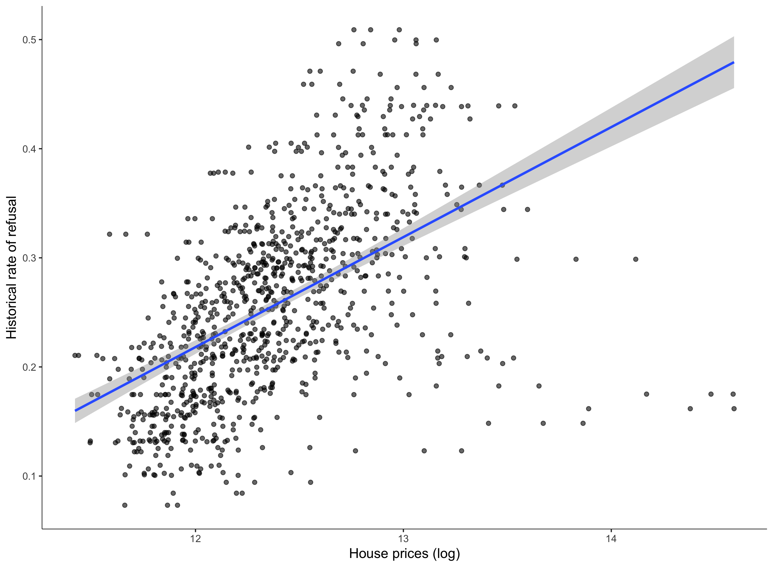

Correlation between urban planning restrictiveness and house prices

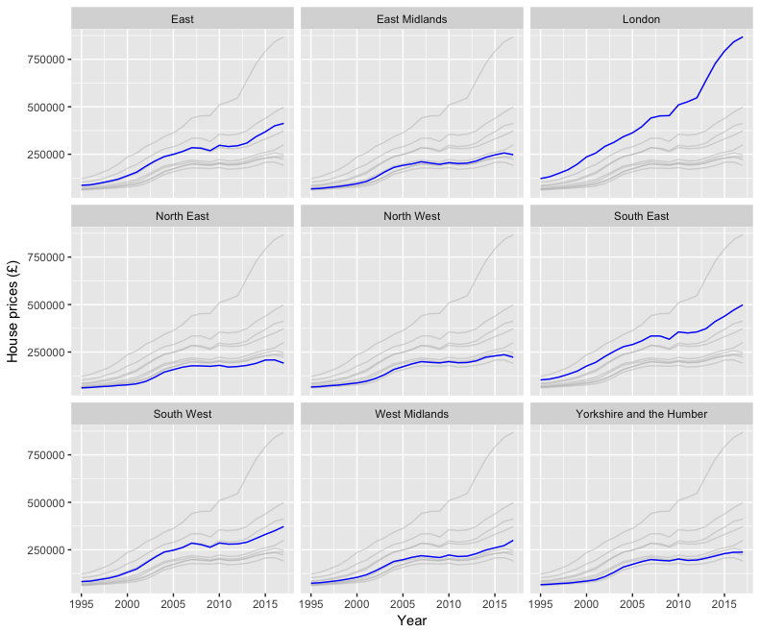

House prices in England, 1995-2017

Source: Office of National Statistics. House prices are deflated to 2000 prices.

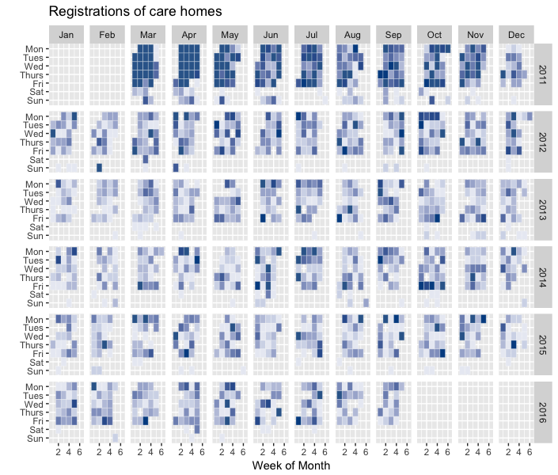

Care homes registrations in the CQC (2011- 2016)

Source: Care Quality Commission.

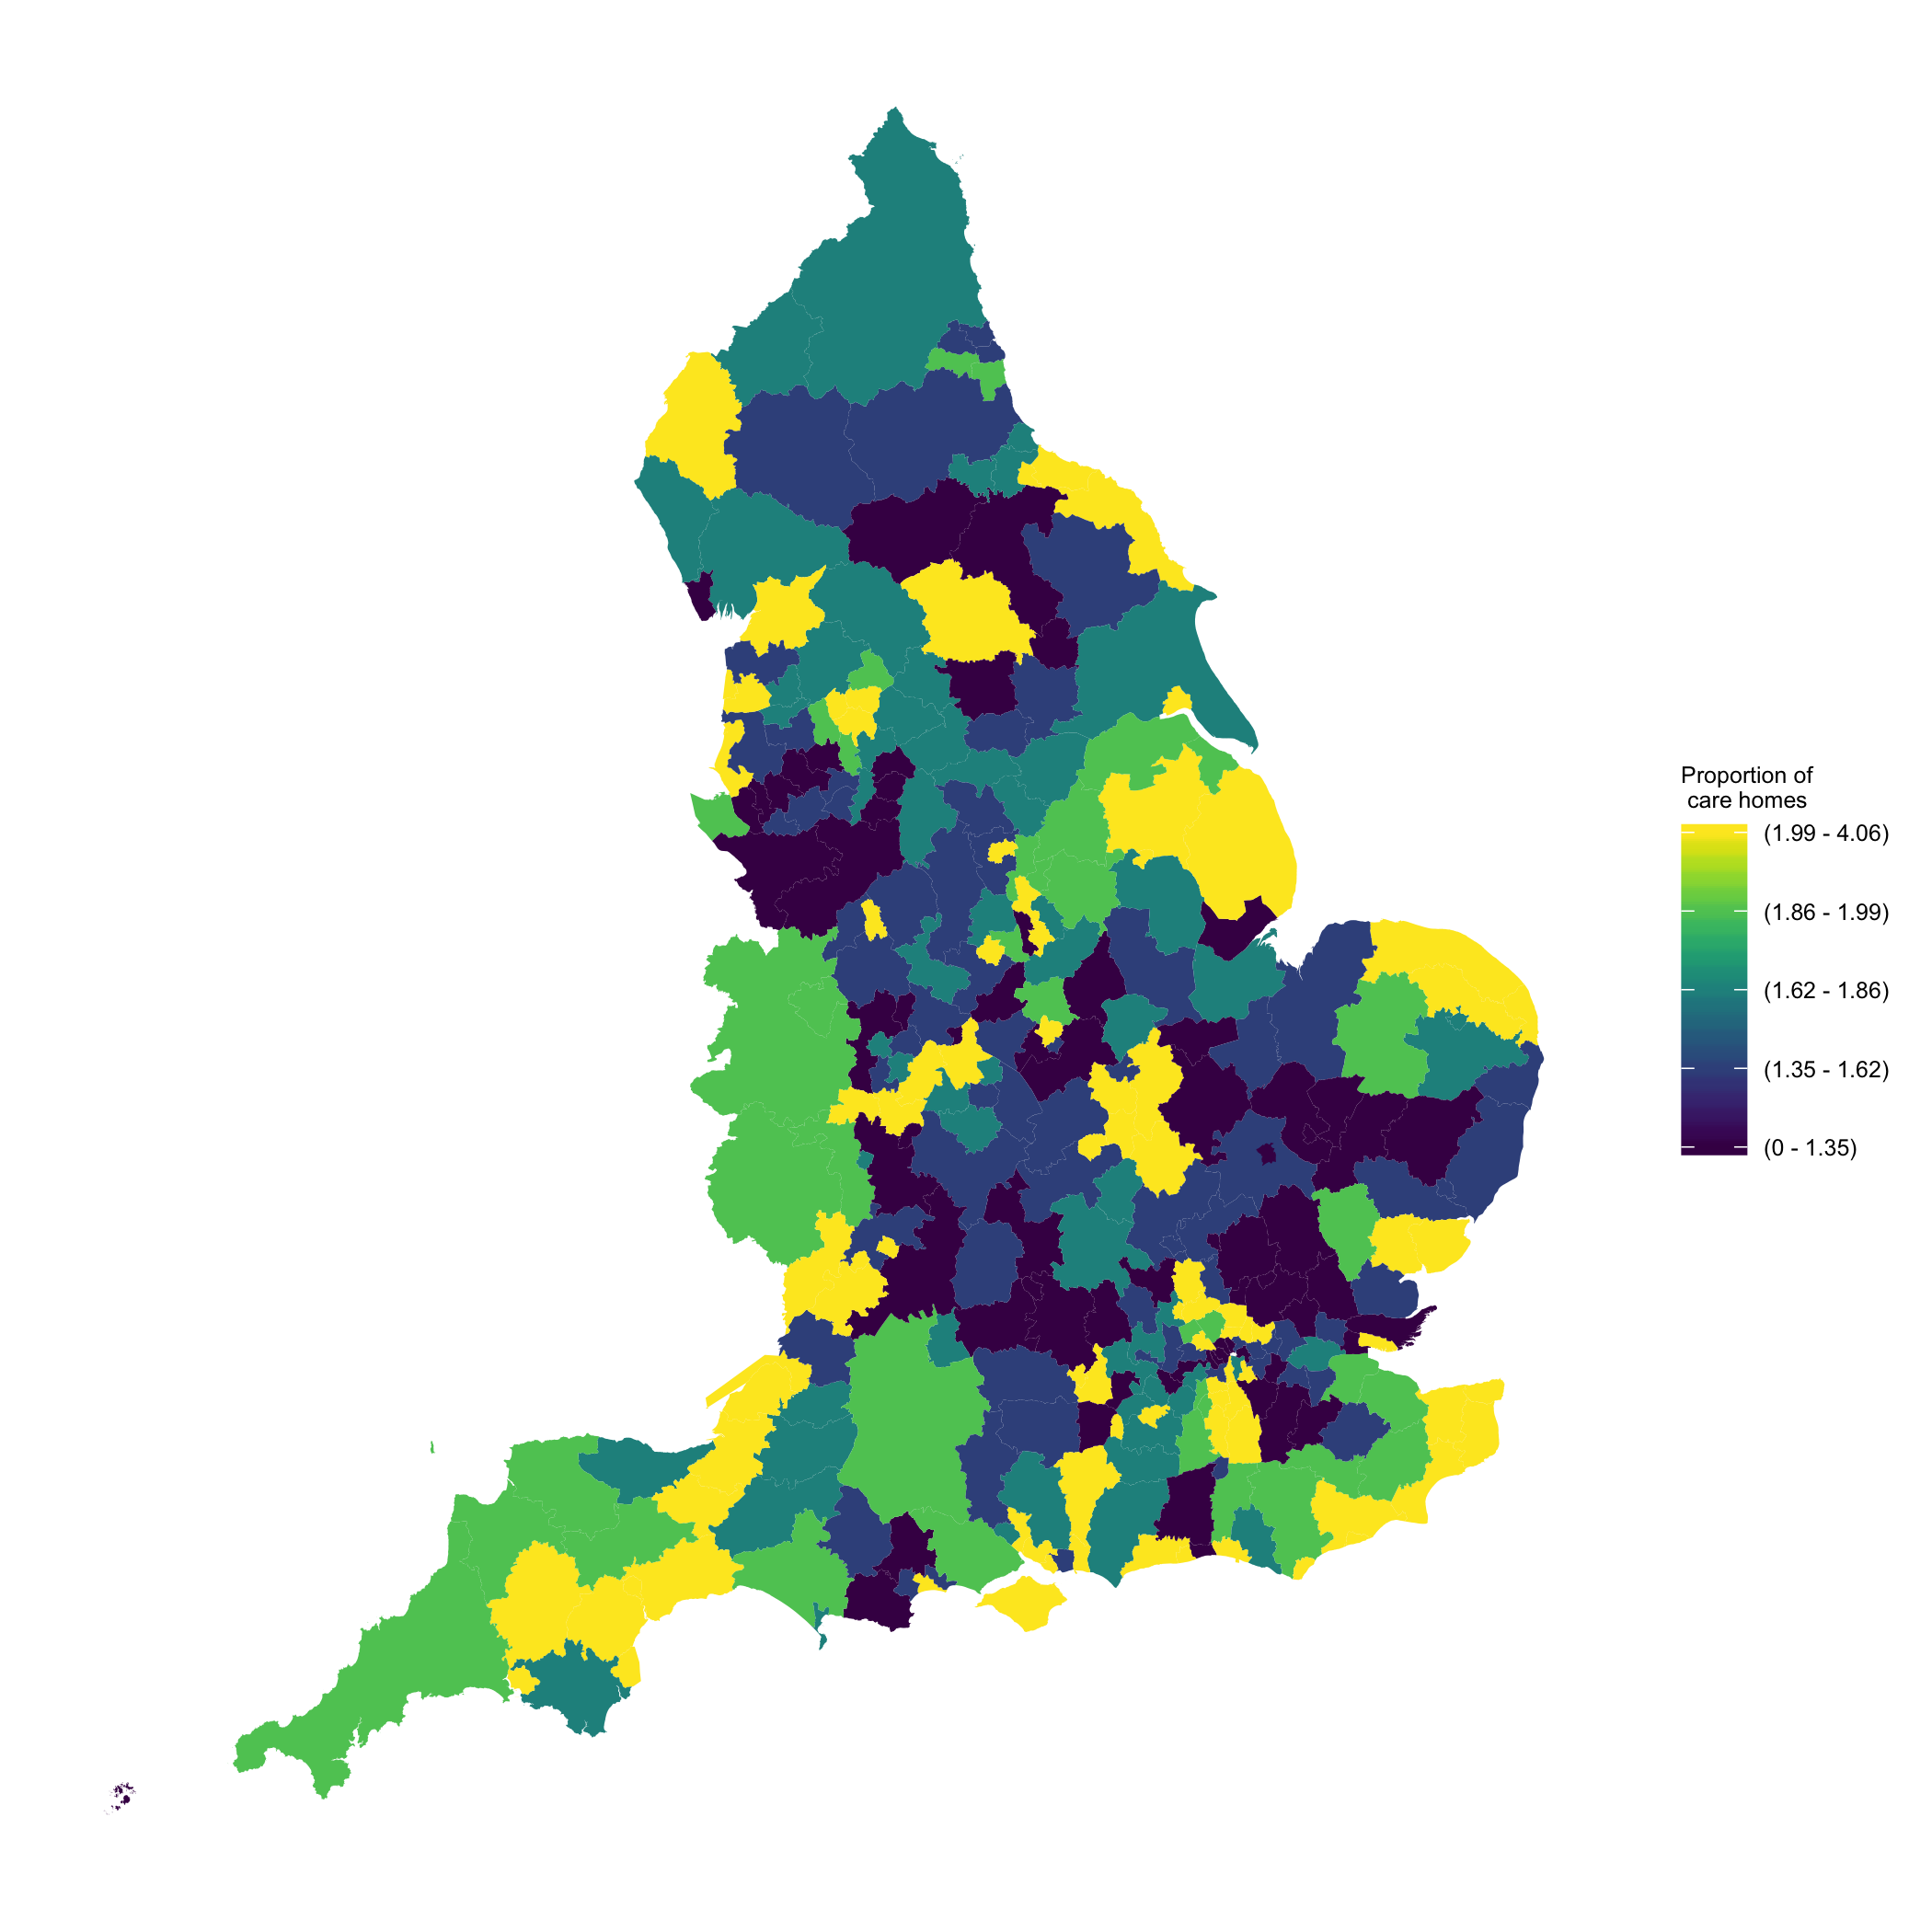

Care homes per 1000 population over 65 - England, district level

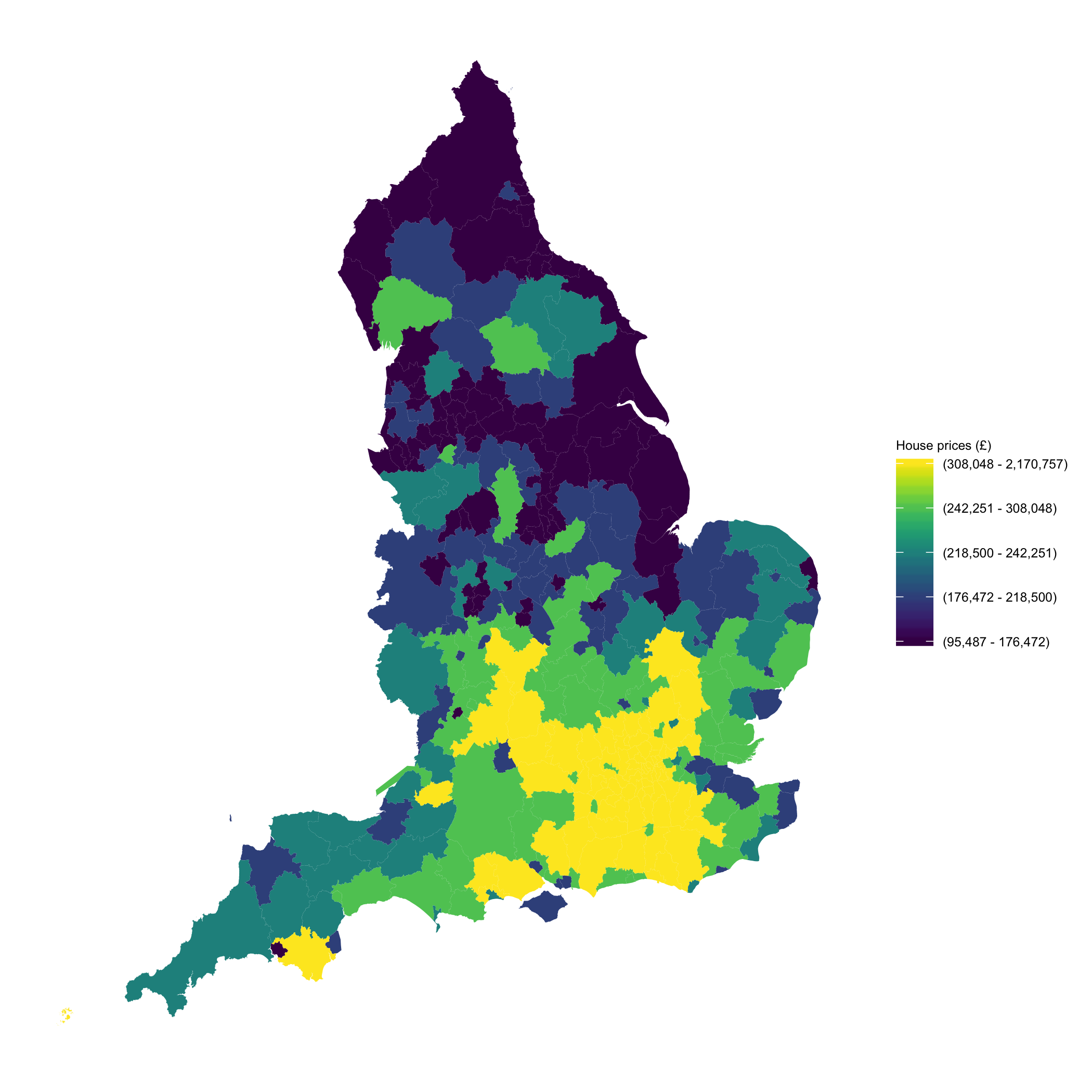

House prices - England, district level

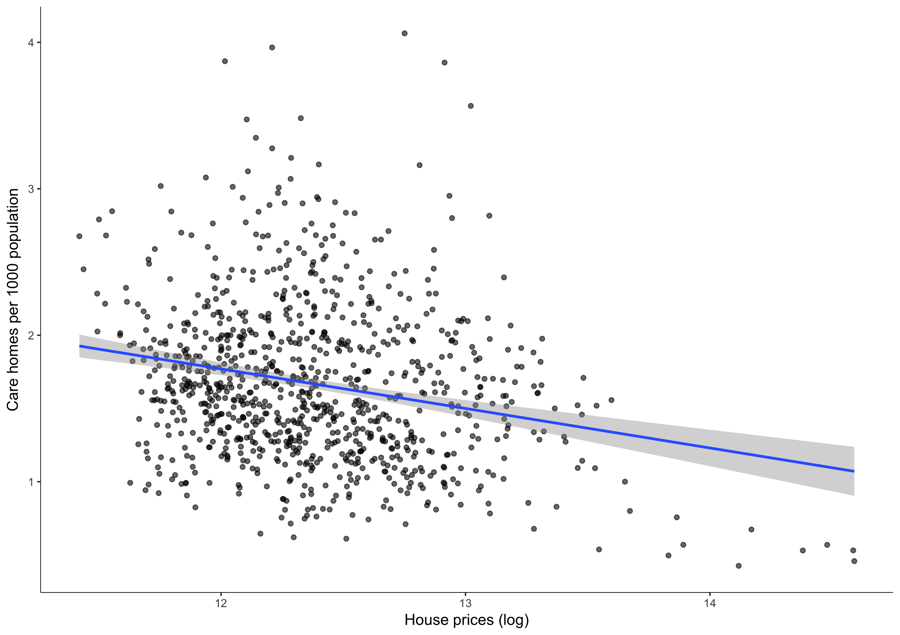

Correlation between care homes and house prices

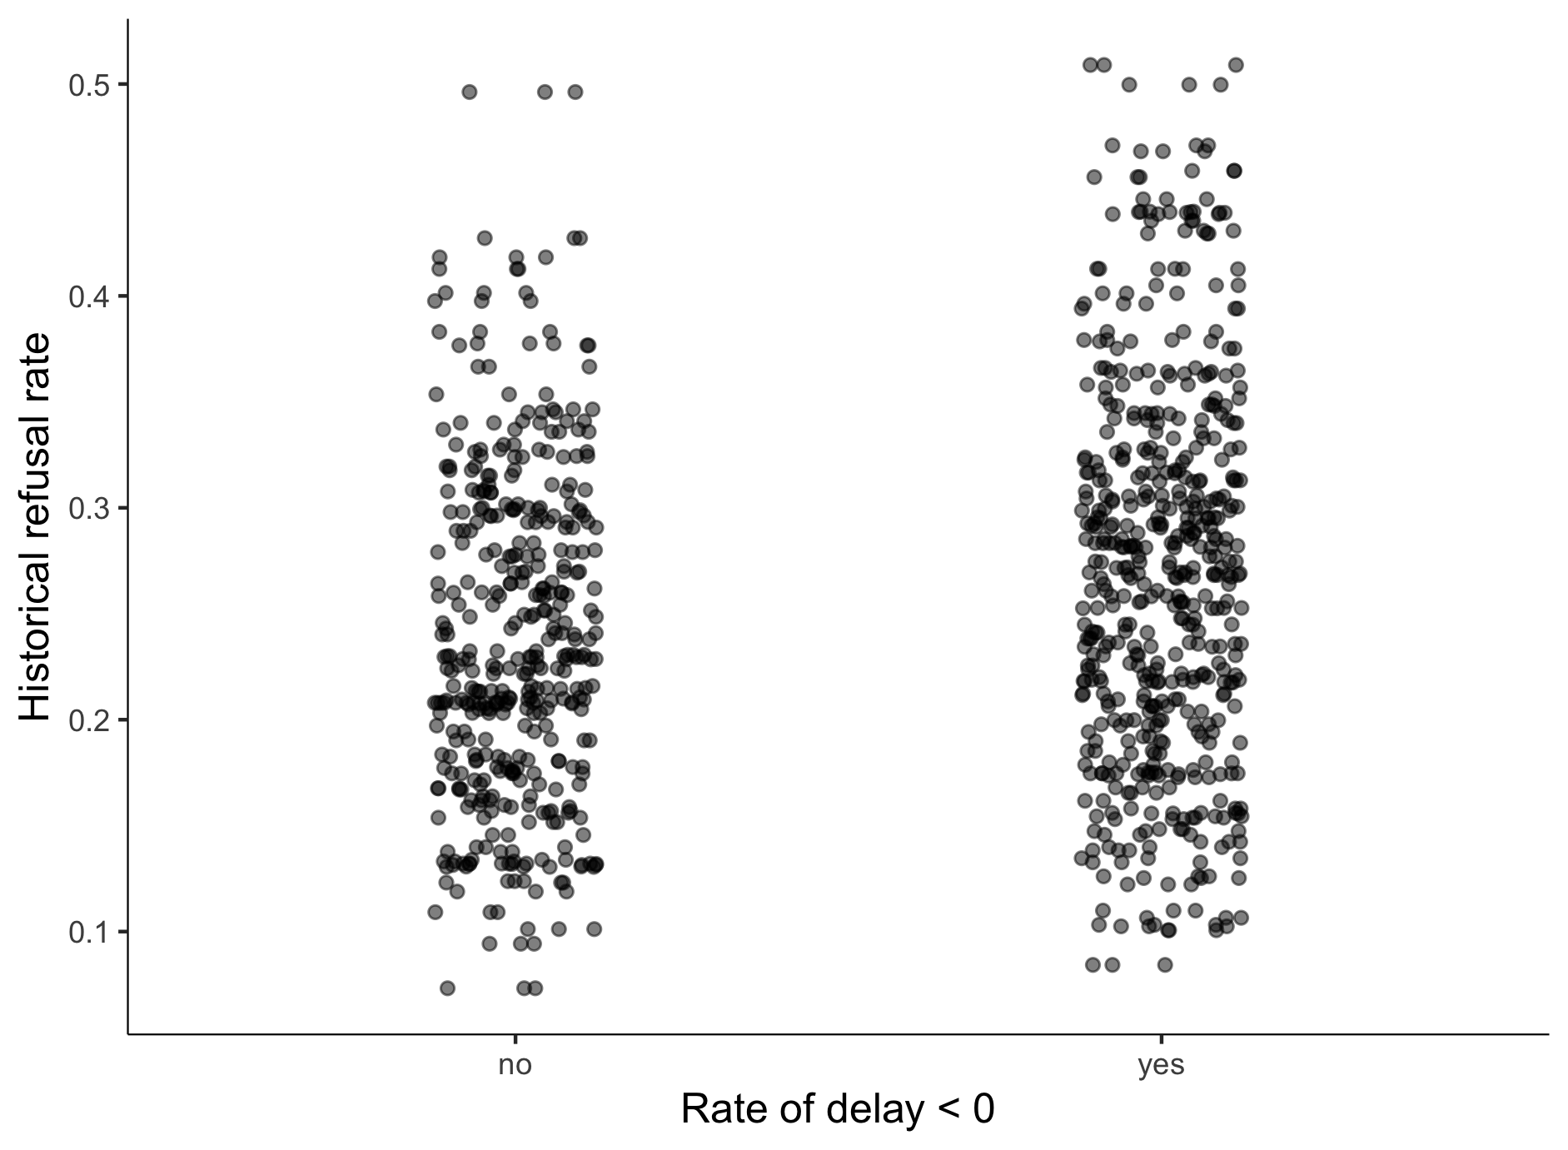

Distribution of house prices

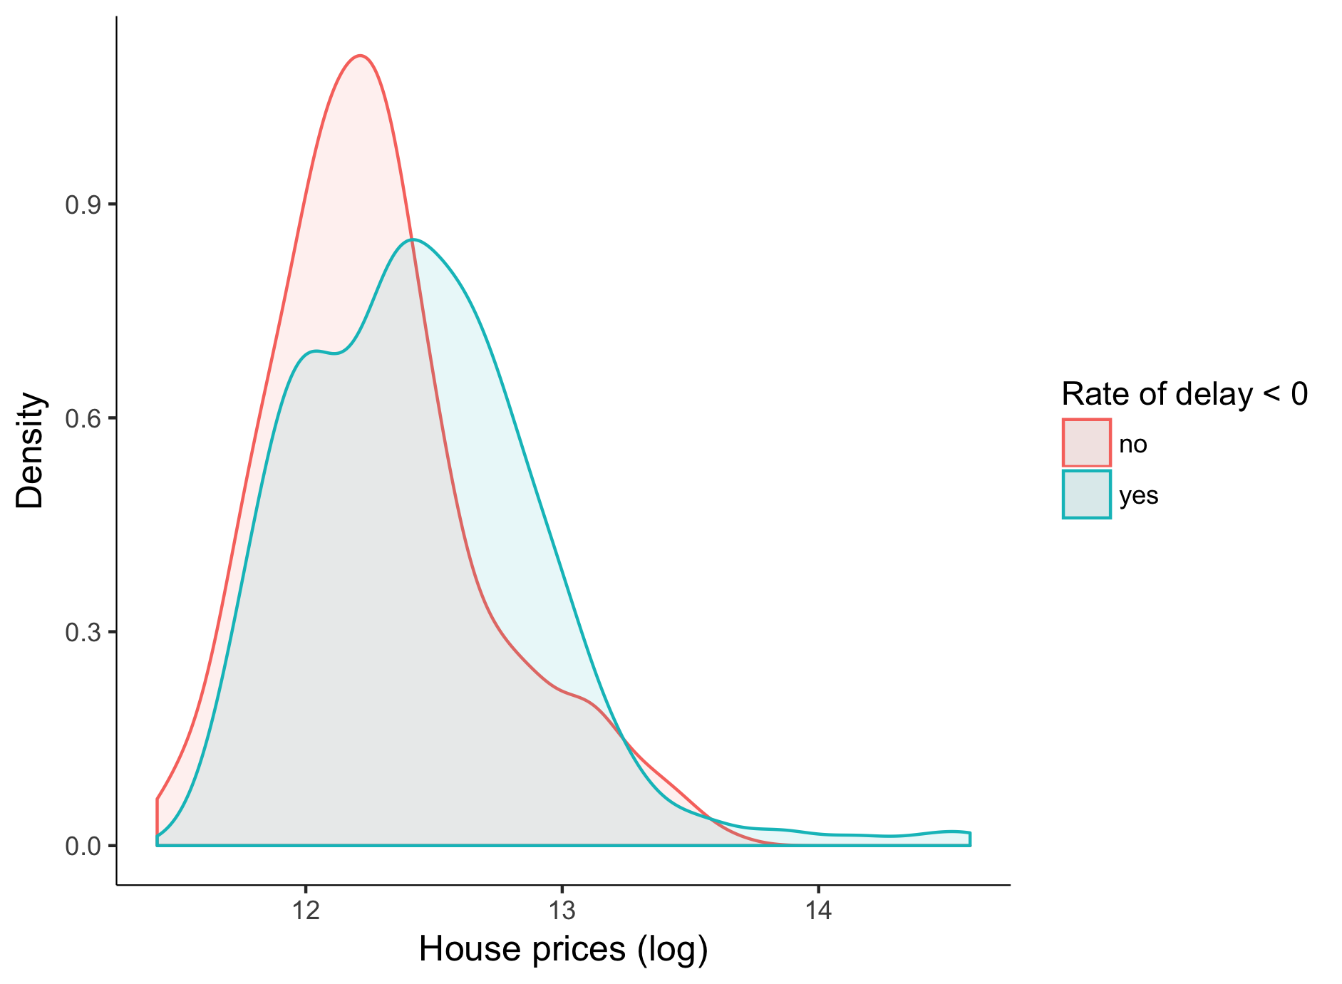

Distribution of house prices

1. Newcastle University Business School. 5 Barrack Rd, Newcastle upon Tyne NE1 4SE
2. Corresponding author:
3. Over the period of 2001 and 2011, the proportion of people over 85 has grown faster than the population as whole. Apart from living longer, this group of population is also more likely to have care needs
4. There is mixed evidence concerning the degree of substituability and complementarity between both types of long term care provision
5. Some representatives of the sector argue that care home developers would be “ *financially driven rather than reflecting the regional demand*”
6. Some areas of England have another tier that includes town and parish councils. This level of local government rules smaller local services.
7. Before 2008, these activities were managed by Primare Care Trusts (PCT). The Health and Social Care Act (2008) transferred public health matters – which included long term care activities among others, from these PCT to local authorities. Other issues where PCT were responsible for, such as clinical and health issues, became responsibility of the clinical commissioning groups (CCG).
8. Considering registered care homes in all sectors, the South East is the region that has more registered care homes (currently more than 1,000). This proportion of care homes contrasts with the North East where there are about 360 registered care homes.
9. This formula has been applied for the delivery of various public services in the UK . Using the nursing and residential care market, Barron and West (2017) analyse the performance in terms quality standards of different types of providers. Their main result suggests that facilities that operate in quasi markets are, on average, of higher quality.1 es have evaluated the effect e associatio g tions and the housing markets. e UK k for d importn for de in this course. Anothe
10. Using information from Laing Buisson market reports, Jarret (2017) argue that publicly funded clients would be about a 50% more than private clients in 2014.
11. This dataset is maintained by the CQC Directorate of Data and Statistics and available upon request.
12. Since October 2010 registration in Care Quality Commission became a legal requirement for every long term care provider wishing to carry out a regulated activity.
13. These dimensions entail the evaluation of issues related to the safety, the effectivity, the level of care and response to people’s needs as well as the management of the services.
14. The difference between these two types properties is based on the whether the ownership of the land or property is for a temporary (*leasehold*) or unrestricted ( *freehold*) period.
15. Further information is provided in the following link: <http://www.data.parliament.uk/dataset/general-election-2015>
16. These districts are Allerdale, Lancaster, Harrogate and Scarborough.
17. This benefit aims to support those people with physical disabilities in UK that live independently and might require residential care services otherwise.
18. This proportion is about 82% in 2016
19. use this instrument for analysing the effect of planning regulations on the proportion of vacant houses in England. They provide housing markets in Greater London as an example of areas that could have changed their voting behaviour as a consequence of these inflows.
20. The statistic resulting from this test is distributed as a distribution under the joint null hypothesis that the instruments are valid instruments.